Applecross Senior High School

Semester One Examination, 2018

Question/Answer booklet

MATHEMATICS

SOLUTIONS
METHODS
UNIT 1

Section Two:

Calculator-assumed

Student number: In figures

In words

Your name

Time allowed for this section
Reading time before commencing work: ten minutes
Working time: one hundred minutes

Materials required/recommended for this section
To be provided by the supervisor
This Question/Answer booklet
Formula sheet (retained from Section One)

To be provided by the candidate
Standard items: pens (blue/black preferred), pencils (including coloured), sharpener,
correction fluid/tape, eraser, ruler, highlighters

Special items: drawing instruments, templates, notes on two unfolded sheets of A4 paper, and up to three calculators approved for use in this examination

Important note to candidates
No other items may be taken into the examination room. It is your responsibility to ensure that you do not have any unauthorised material. If you have any unauthorised material with you, hand it to the supervisor before reading any further.

Structure of this paper

Section | Number of questions available | Number of questions to be answered | Working  time (minutes) | Marks available | Percentage of examination
Section One:  Calculator-free | 8 | 8 | 50 | 52 | 35
Section Two:  Calculator-assumed | 13 | 13 | 100 | 98 | 65
 |  |  |  | Total | 100

Instructions to candidates

1. The rules for the conduct of examinations are detailed in the school handbook. Sitting this examination implies that you agree to abide by these rules.

2. Write your answers in this Question/Answer booklet.

3. You must be careful to confine your response to the specific question asked and to follow any instructions that are specified to a particular question.

4. Supplementary pages for the use of planning/continuing your answer to a question
have been provided at the end of this Question/Answer booklet. If you use these pages to continue an answer, indicate at the original answer where the answer is continued, i.e. give the page number.

5. Show all your working clearly. Your working should be in sufficient detail to allow your answers to be checked readily and for marks to be awarded for reasoning. Incorrect answers given without supporting reasoning cannot be allocated any marks. For any question or part question worth more than two marks, valid working or justification is required to receive full marks. If you repeat any question, ensure that you cancel the answer you do not wish to have marked.

6. It is recommended that you do not use pencil, except in diagrams.

7. The Formula sheet is not to be handed in with your Question/Answer booklet.

Section Two: Calculator-assumed 65% (98 Marks)
This section has thirteen (13) questions. Answer all questions. Write your answers in the spaces provided.

Working time: 100 minutes.

Question 9 (4 marks)
The graphs of $y=2x^{2}+2x+c$, $y=a{\left(x-2\right)}^{2}+1$ and $y=(x+b)(x+3)$ are shown below.

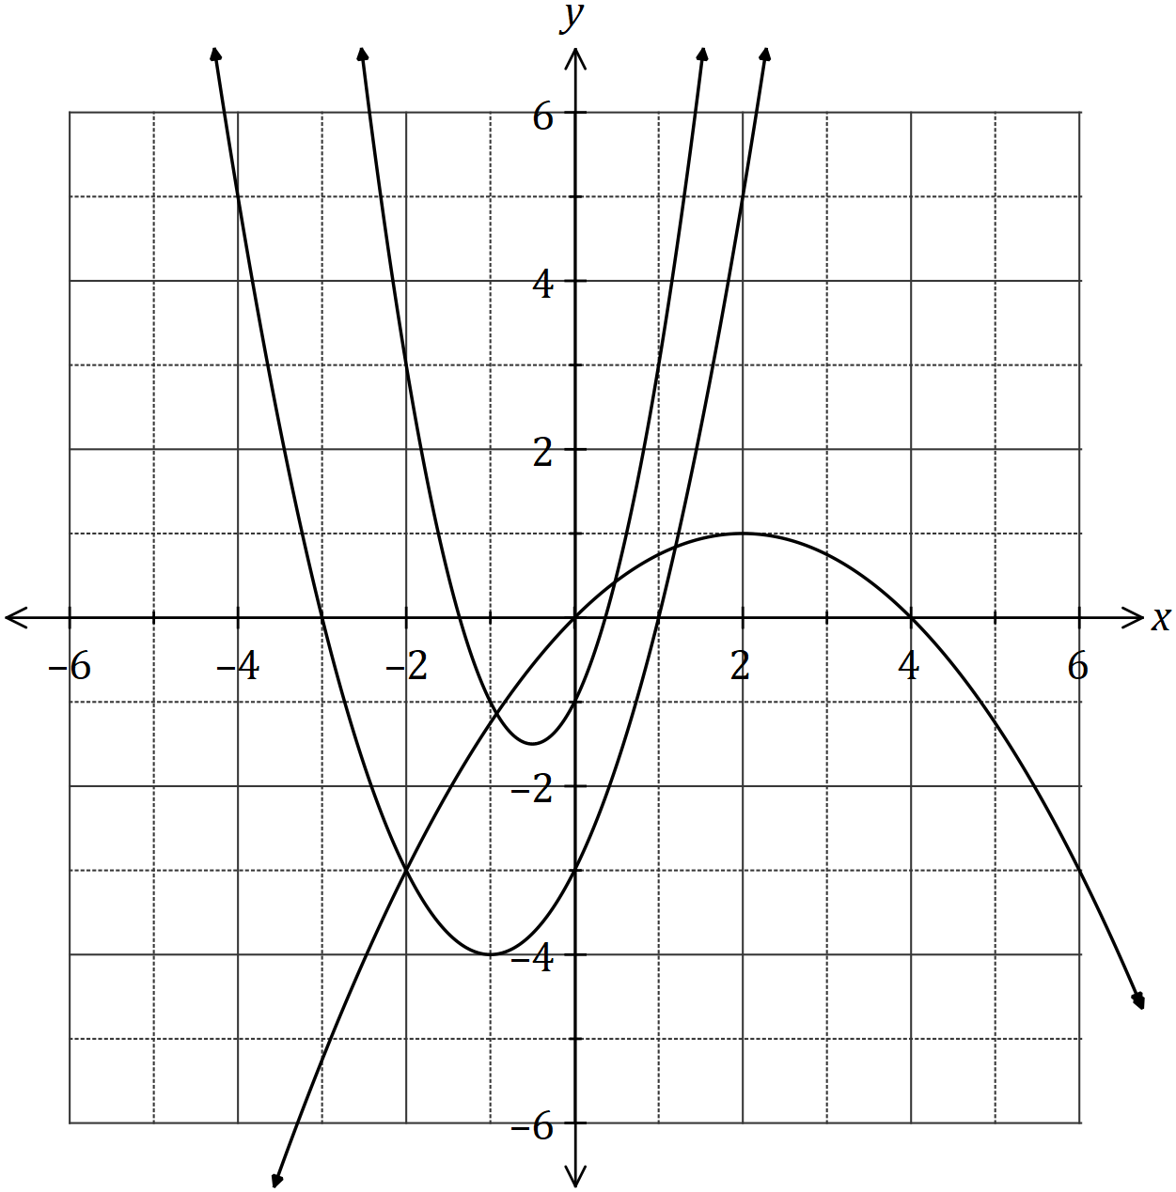

Determine the values of the constants $a, b$ and $c$.
Solution
$$x=4⇒0=a{\left(4-2\right)}^{2}+1$$
$$a=-\frac{1}{4}$$

$$b=-1 \text{(Other root at -3)}$$

$$c=-1 \text{(y-intercept)}$$

Specific behaviours
uses point on inverted parabola
value of $a$
value of $b$
value of $c$

Question 10 (7 marks)
(a) The graph of a relationship is circular, as shown below.

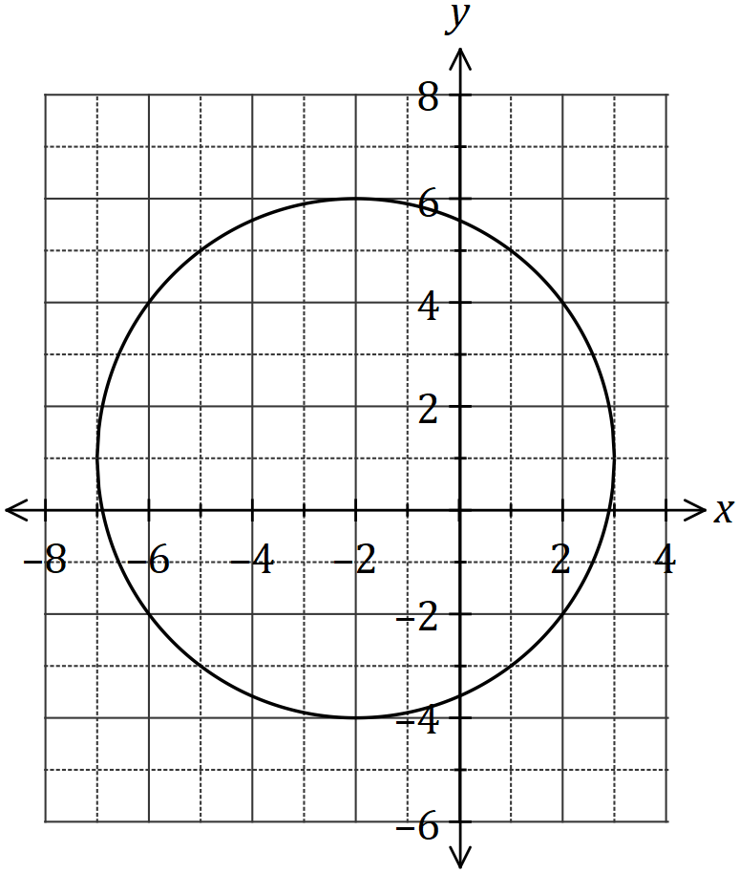

Determine the equation of this circle in the form $x^{2}+y^{2}=a+bx+cy$, where $a, b$ and $c$ are constants. (4 marks)
Solution
$$\text{Centre at} \left(-2, 1\right)\text{and} r=5$$

$${\left(x+2\right)}^{2}+{\left(y-1\right)}^{2}=5^{2}$$

$$x^{2}+y^{2}=20-4x+2y$$

Specific behaviours
indicates centre
indicates radius
factored form
re-arranges as required

(b) The line $x+y+1=0$ intersects the circle at the points $A$ and $B$. Show that the line passes through the centre of the circle, and hence determine the distance $AB$. (3 marks)
Solution
$$\text{Sub centre} \left(-2,1\right): -2+1+1=0$$
$$\text{Hence line passes through centre}$$

$$AB \text{is a diameter}$$

$$AB=2×5=10$$

Specific behaviours
correct substitution
indicates $AB$ is diameter
correct distance

Question 11 (6 marks)
A thin pole stands vertically in the middle of a level playing ground. From point $A$ on the ground, the angle of elevation to the top of the pole, $T$, is 18º.

From point $B$, also on the ground but 5.35 metres further from the foot of the pole than $A$, the angle of elevation to the top of the pole is 15º.

(a) Draw a sketch to represent this information. (1 mark)
Solution
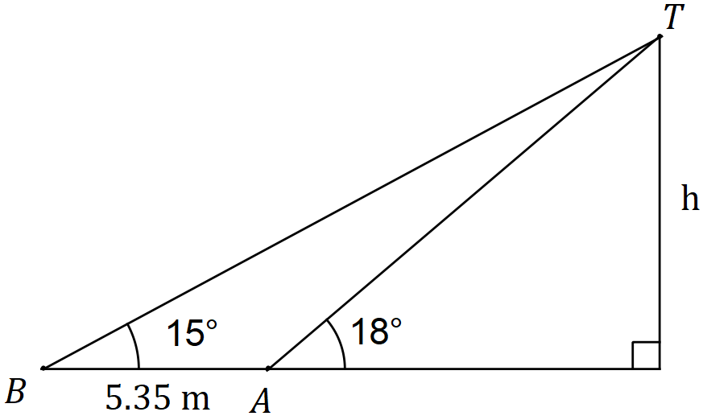
Specific behaviours
sketch with right-angle, two given angles and distance AB

(b) Showing use of trigonometry, determine the height of the post. (5 marks)
Solution
$$\frac{AT}{\sin{15}}=\frac{5.35}{\sin{3}}⇒AT=26.46$$

$$h=26.46×\sin{18}=8.18$$

Specific behaviours
angle $BTA$
equation using sine rule
solves for AT
use of trig in right triangle
determines h

Question 12 (7 marks)
Let $f\left(x\right)=\begin{matrix}4 \\ \overline{3-x}\end{matrix}$ and $g\left(x\right)=\begin{matrix}1 \\ \overline{x+p}\end{matrix}+q$, where $p$ and $q$ are constants.

The graph of $y=g(x)$ is shown below.

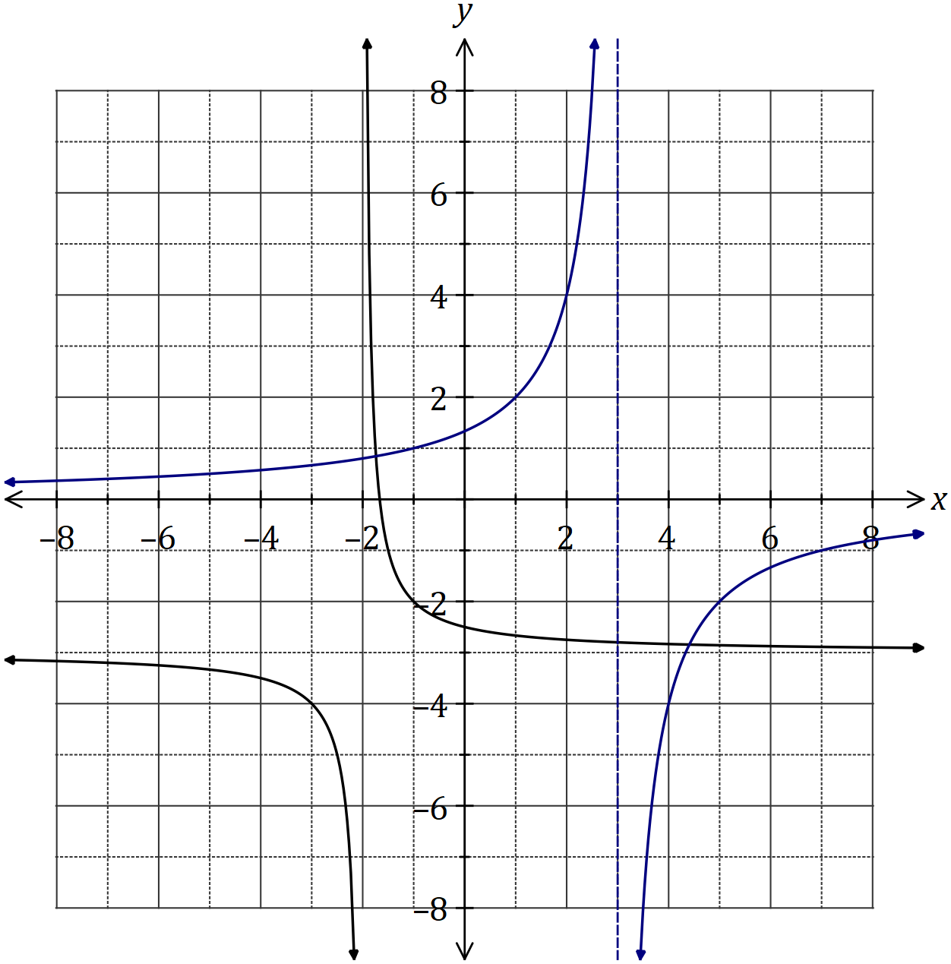
Solution
See graph
Specific behaviours
asymptotes
y-intercept
accuracy [i.e. thu' at least 3 of (-1,1), (1,2), (2,4), (4,-4) or (7,-1)]

(a) Sketch the graph of $y=f(x)$ on the axes above. (3 marks)

(b) Determine the values of $p$ and $q$. (2 marks)
Solution
$$p=2, q=-3$$

Specific behaviours
value of $p$
value of $q$

(c) Solve the equation $f\left(x\right)=g(x)$, giving your solution(s) to one decimal place. (2 marks)
Solution
$$x=-1.7, x=4.4$$

Specific behaviours
one solution
second solution
(Rounding for guidance only but penalise answers given as coordinates)

Question 13 (6 marks)
(a) Determine the equation of the axis of symmetry for the graph of $y=3x^{2}+12x+40$.
(2 marks)
Solution
$$x=-\frac{b}{2a}=-\frac{12}{2×3}=-2$$

$$x=-2$$

Specific behaviours
indicates use of formula
correct equation

(b) The graph of $y=ax^{2}+bx+13$ passes through the points $(-3,-23)$ and $(4, 5)$. Determine the values of the constants $a$ and $b$. (4 marks)
Solution
$$-23={\left(-3\right)}^{2}a-3b+13$$
$$-23=9a-3b+13$$

$$5=4^{2}a+4b+13$$
$$5=16a+4b+13$$

Solve simultaneously using CAS

$$a=-2, b=6$$

Specific behaviours
substitutes first point
substitutes second point
solves for $a$
solves for $b$

Question 14 (10 marks)
A logo with triangular outline $ABC$ contains a shaded segment bounded by the straight line $PM$ and the circular arc $PM$ with centre $B$ and radius $BM=18$ cm, as shown below.

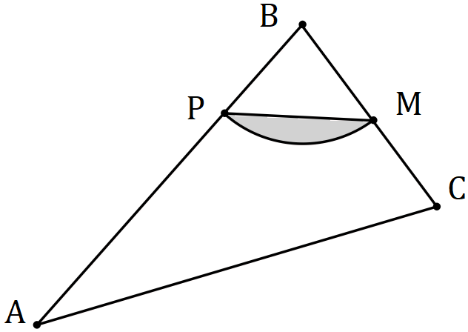

Given that $∠ABC=\begin{matrix}5π \\ \overline{12}\end{matrix}$, $∠BCA=2∠BAC$ and $M$ is the midpoint of $BC$, determine

(a) the size of $∠ABC$ in degrees. (1 mark)
Solution
$$\frac{5π}{12}×\frac{180}{π}=75°$$

Specific behaviours
converts angle

(b) the area of the shaded segment. (2 marks)
Solution
$$A=\frac{1}{2}{\left(18\right)}^{2}\left(\frac{5π}{12}-\sin\left(\frac{5π}{12}\right)\right)≈55.6 {\text{cm}}^{2}$$

Specific behaviours
indicates substitution into segment area formula
evaluates area

(c) the perimeter of the shaded segment. (3 marks)
Solution
$$PM_{arc}=18×\frac{5π}{12}=\frac{15π}{2}≈23.56$$

$$b=\sqrt{{18}^{2}+{18}^{2}-2\left(18\right)\left(18\right)\cos{75}}≈21.92$$

$$\text{Perimeter}=23.56+21.92≈45.5 \text{cm}$$

Specific behaviours
calculates arc length
indicates use of cosine rule to find $PM$
evaluates $PM$ and states perimeter

(d) the area of triangle $ABC$. (4 marks)
Solution
$$∠A+∠C=180-75$$
$$∠A+2∠A=105⇒∠A=35$$

$$\frac{AC}{\sin{75}}=\frac{2×18}{\sin{35}}$$

$$AC=60.63$$

$$\text{Area}=\frac{1}{2}\left(36\right)\left(60.63\right)\sin\left(2×35\right)≈1025 {\text{cm}}^{2}$$

Specific behaviours
indicates use of equation to find second angle
evaluates second angle and indicates use in sin rule
evaluates second side
evaluates triangle area

Question 15 (9 marks)
(a) The graphs of the following, where $a, b, c, d, e$ and $f$ are constants, are shown below.

$$y=\sin\left(ax\right) y=b\cos{(x)} y=\tan{(cx)} y=d\sin\left(x\right) y=\cos\left(ex\right) y=f\tan{(x)}$$

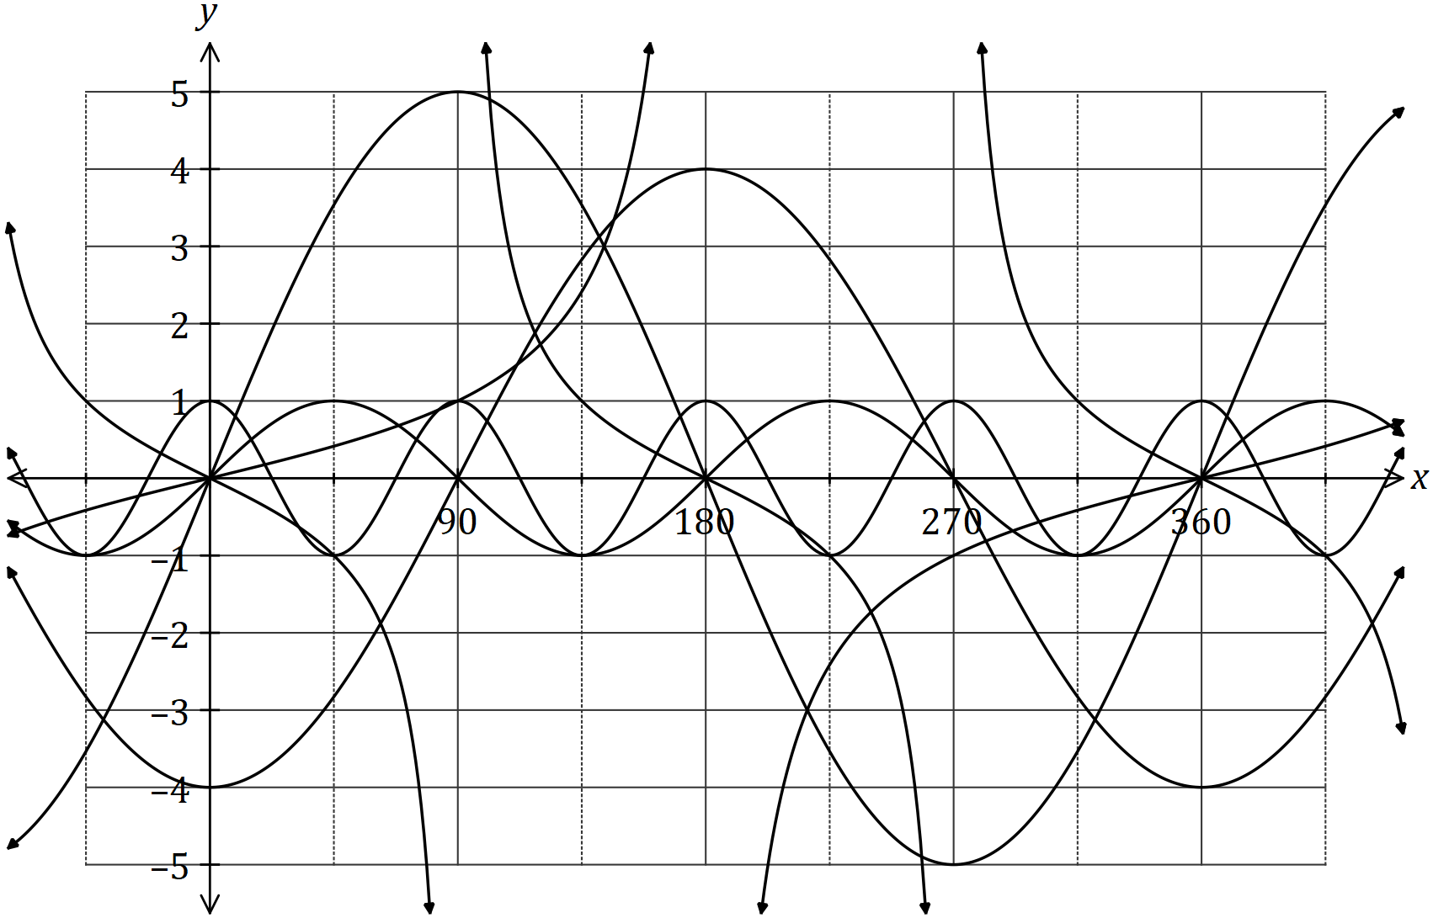

State the values of $a, b, c, d, e$ and $f$. (6 marks)

Constant | Value
$$a$$ | 2
$$b$$ | -4
$$c$$ | 0.5
$$d$$ | 5
$$e$$ | 4
$$f$$ | -1

Solution
See table
Specific behaviours
each value

(b) Calculate the acute angle in degrees between the lines $y=x+5$ and $y=3x-1$, rounding your answer to one decimal place. (3 marks)
Solution
$$α=\tan^{-1}{(1)}=45°$$

$$β=\tan^{-1}\left(3\right)=71.565°$$

$$β-α=26.6° (\text{1 dp})$$

Specific behaviours
angle of inclination of first line
angle of inclination of second line
acute angle, to one decimal place

Question 16 (6 marks)
(a) The graph of $y=f\left(x\right)$ is shown in bold below. The graphs of $y=-f\left(x\right), y=f(x+p)$ and $y=f\left(x\right)+q$ are also shown, where $p$ and $q$ are constants.

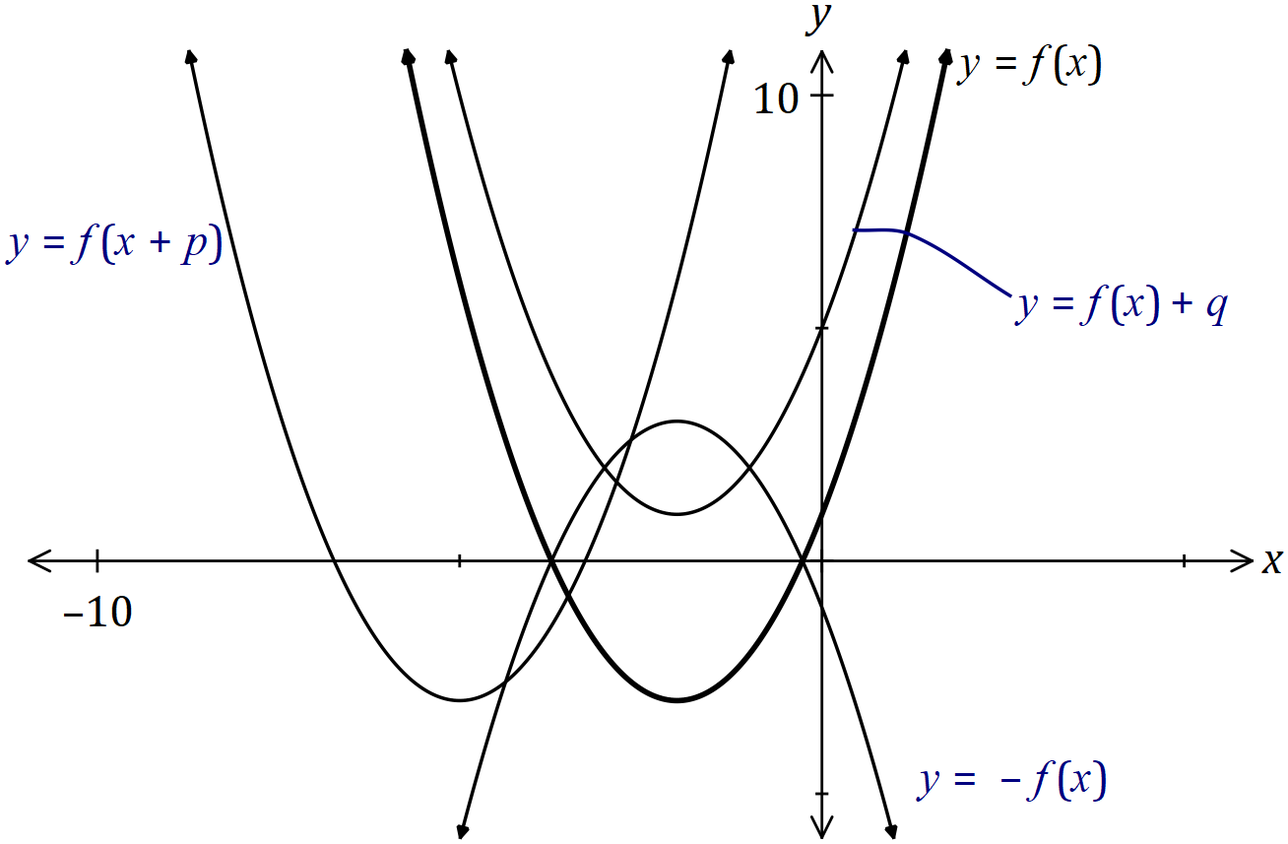
Solution
See graph
Specific behaviours
each correct label

Clearly label the remaining graphs with $y=-f\left(x\right), y=f(x+p)$ or $y=f\left(x\right)+q$.
(3 marks)

(b) The one-to-one relation $y=7-3x$ has domain and range given by $\{x:x=-2, 3, a\}$ and $\{y:y=-8,-2, b\}$ respectively. Determine the values of constants $a$ and $b$. (3 marks)
Solution
$$x=3, y=-2$$

$$x=-2, y=13=b$$

$$x=a, y=7-3a=-8⇒a=5$$

Specific behaviours
value of $b$
indicates $a \text{is mapped onto} -8$
solves for value of $a$

Question 17 (9 marks)
The wind speed at a weather station, $v$ metres per second, $t$ hours after recording began, can be modelled by the function

$$v=20-5.8t+0.75t^{2}-0.02t^{3}, 0≤t≤24$$

(a) Calculate the wind speed when $t=11$. (1 mark)
Solution
$$v\left(11\right)=20.33 \text{m/s}$$

Specific behaviours
value

(b) Sketch the graph of wind speed against time on the axes below. (4 marks)

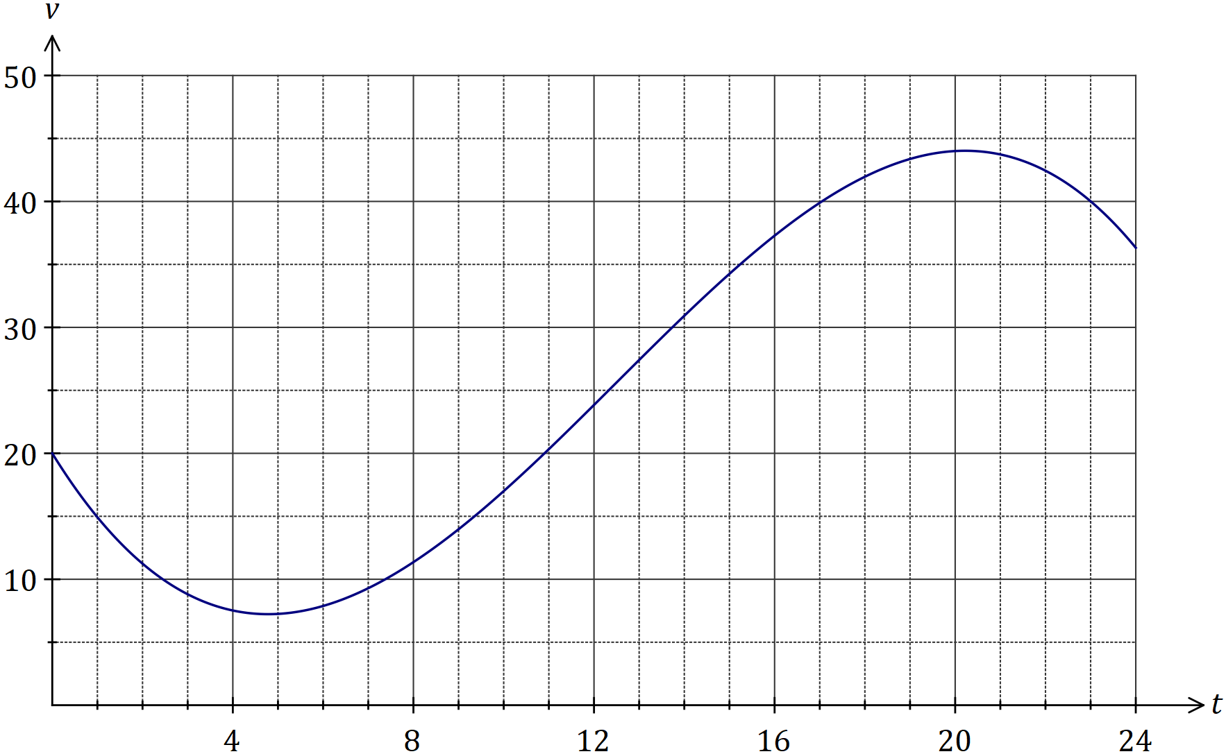
Solution
See graph
Specific behaviours
$(0, 20)$ and $(24, 36)$
min at $≈(5, 7)$
max at $≈(20, 44)$
reasonable curve

(c) During the 24-hour period, determine

(i) the time at which the wind speed was greatest. (1 mark)
Solution
$$t=20.2 \text{h}$$
Specific behaviours
value (at least 1dp)

(ii) the minimum wind speed. (1 mark)
Solution
$$v_{MIN}≈7.23 \text{m/s}$$
Specific behaviours
value (at least 1 dp)

(iii) the length of time, in hours and minutes, that the wind speed was increasing.
(2 marks)
Solution
$$20.219-4.781=15.438$$
$$=15 \text{h} 26 \text{min}$$
Specific behaviours
interval in hours
interval in hours and minutes

Question 18 (6 marks)
(a) Part of the graph of $y=f(x)$ is shown below, where $f\left(x\right)=-2{\left(x-b\right)}^{3}+c$, and $b$ and $c$ are constants.

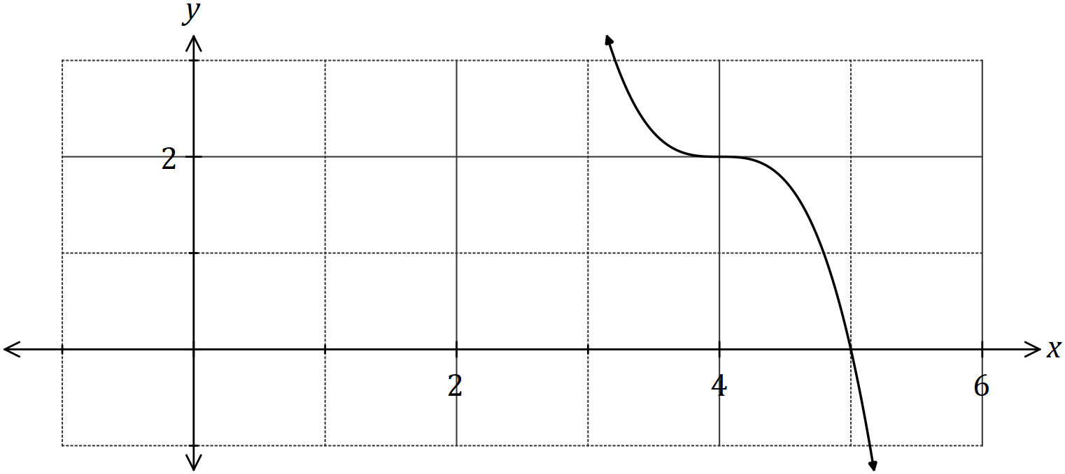

(i) State the degree of $f(x)$. (1 mark)
Solution
$$3$$
Specific behaviours
correct degree

(ii) Determine the value of $b$. (1 mark)
Solution
$$b=4$$
Specific behaviours
correct value

(iii) Determine $f(0)$. (2 marks)
Solution
$$f\left(x\right)=-2{\left(x-4\right)}^{3}+2$$

$$f\left(0\right)=-2{\left(-4\right)}^{3}+2=130$$

Specific behaviours
indicates value of $c$
evaluates

(b) Another function is given by $g\left(x\right)=f(x+8)$.

Describe how to obtain the graph of $y=g(x)$ from the graph of $y=f(x)$. (2 marks)
Solution
Translate graph 8 units to the left.

Specific behaviours
uses translation
indicates distance and direction

Question 19 (13 marks)

(a) The cross-section of a wooden hand rail is formed by the intersection of two quadratic functions shown below. The upper curve is modelled by the equation 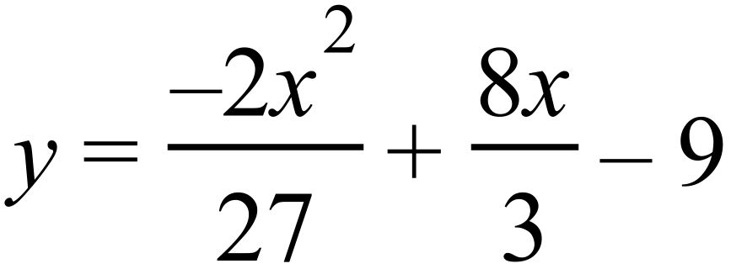 .
The equation of the lower curve is a quadratic of the form 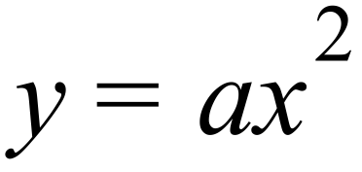 .
The two curves meet at 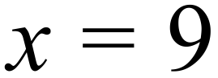 .
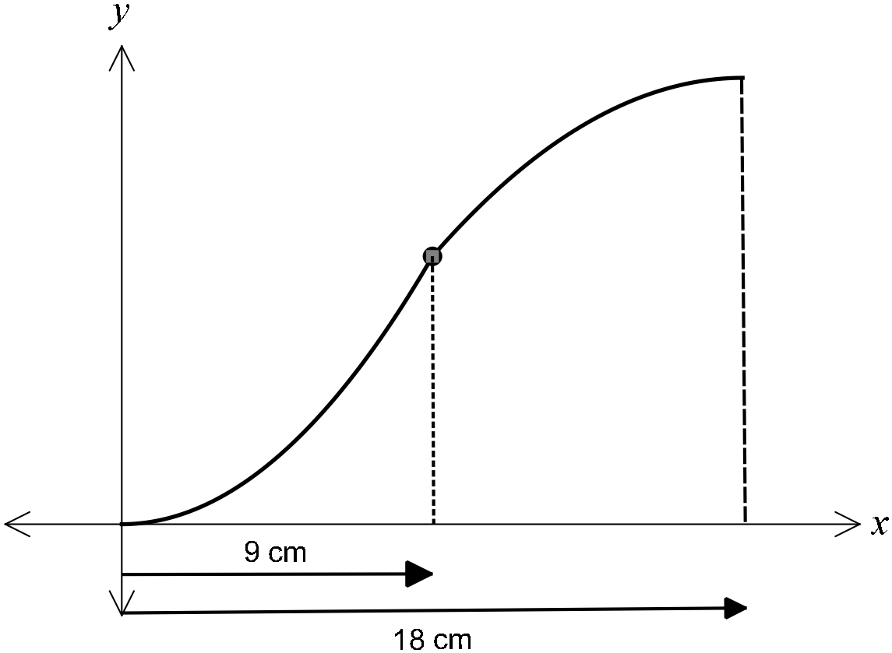

(i) Determine the coordinates of the point where the two curves meet. (1 marks)

Solution
substitute  into upper curve and get
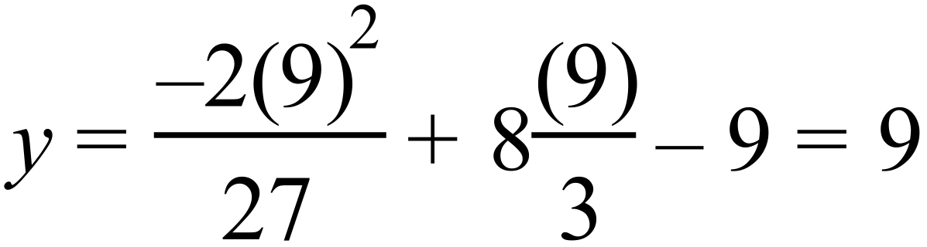 therefore coordinates are (9, 9)
Specific behaviours
- substitutes x = 9 into upper curve and states coordinates

(ii) Determine and hence state the equation of the lower curve (2 marks)

Solution
using the coordinate (9, 9)
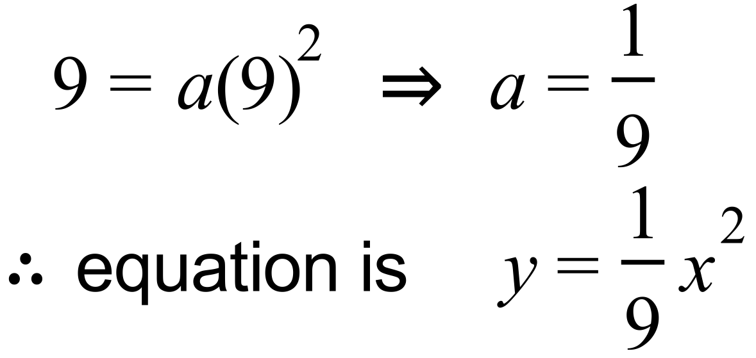
Specific behaviours
- substitutes x = 9 into lower curve to obtain the value of a
- states equation of lower curve

(iii) If the hand rail was moved up 3 cm, determine the new equations of the upper
and lower curves. (1 marks)
Solution
new upper curve: 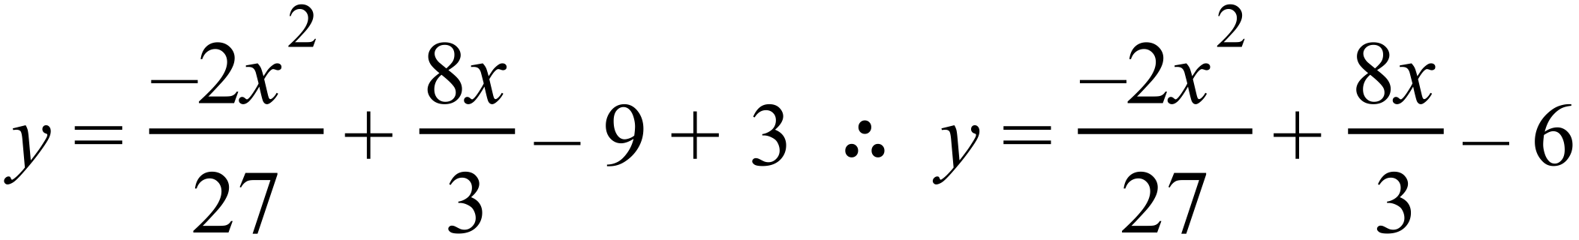
new lower curve: 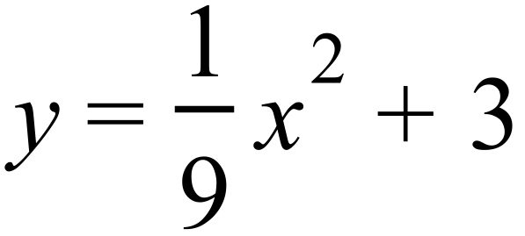
Specific behaviours
- states equation of new upper curve and states equation of new lower curve
(b) Determine the equation
(i) of the line passing through the point 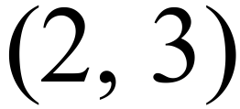 and parallel to the line with
equation 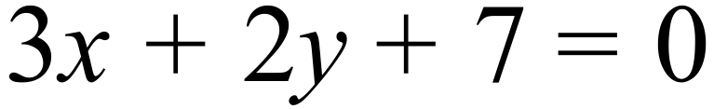 (2 marks)
Solution
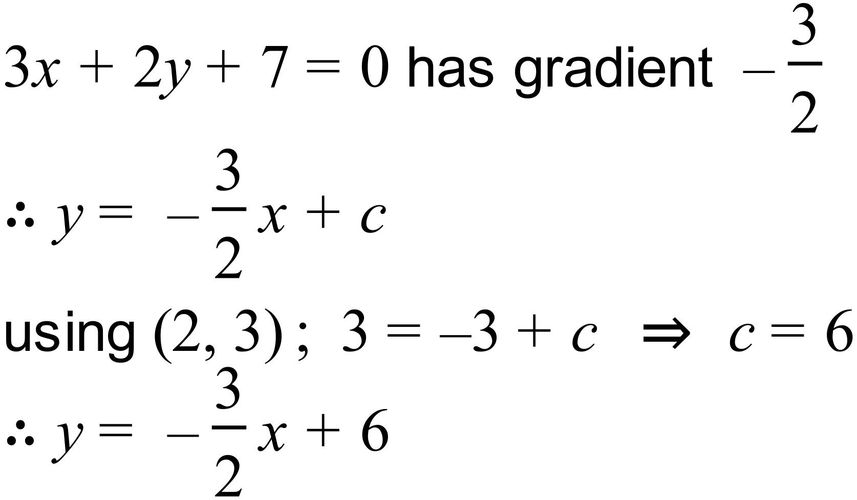
Specific behaviours
- calculates gradient
- uses the given point to calculate c and states equation
(ii) of the line which is the reflection of the line 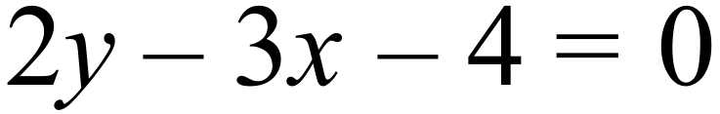 in the y-axis (2 marks)
Solution
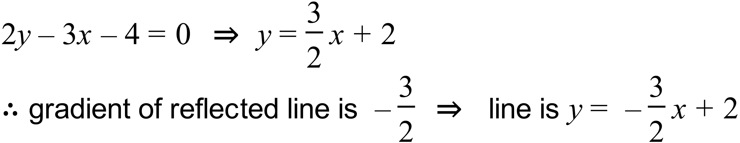
Or note the $x$ is replaced with $-x$. ⇒ line is $2y+3x-4=0$
Specific behaviours
- calculates gradient
- uses the given point to calculate c and states equation
(c) Consider a rope fixed at B and tightly wrapped around a disc A as shown in the diagram below.
Solution
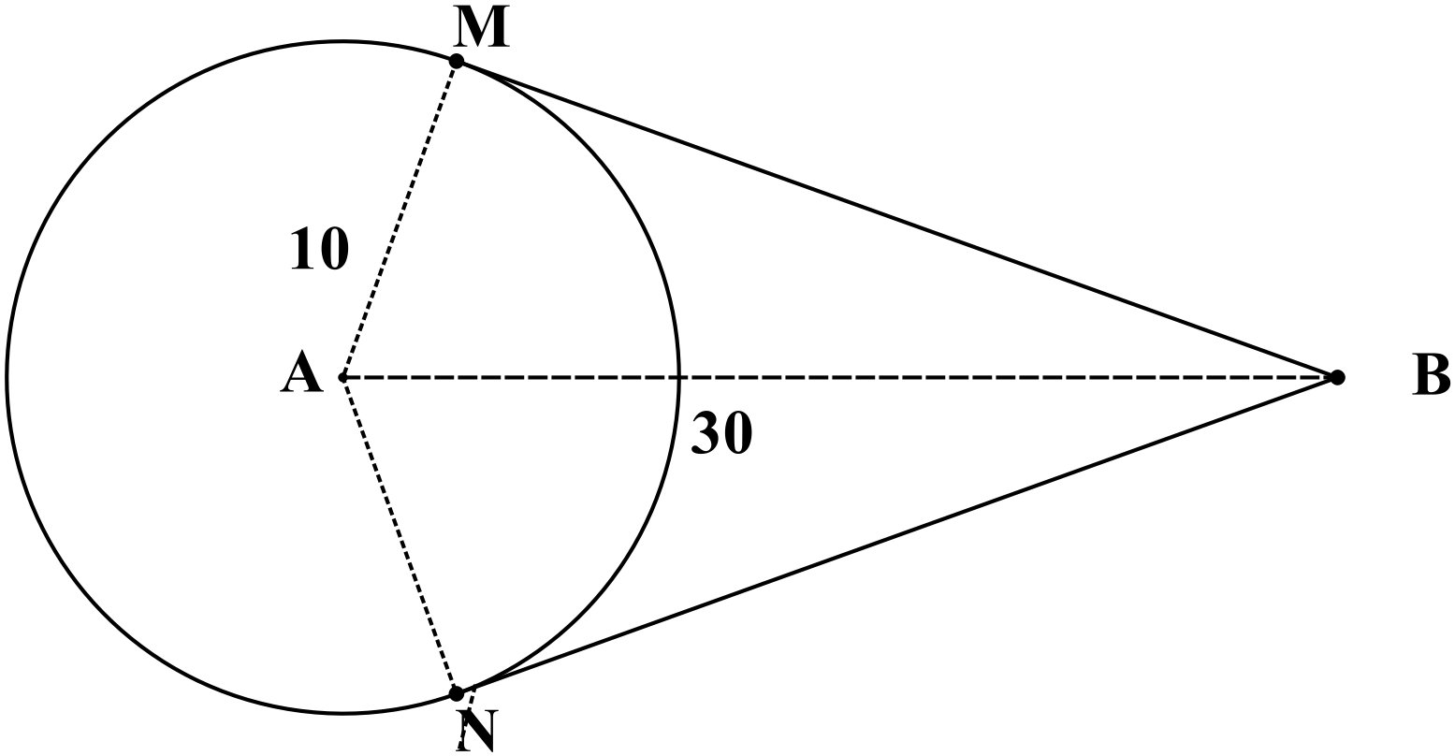
∴length of major arc MN = (2π $-$ 2.462) x 10 = 38.213
Hence the length of the rope cm
Specific behaviours
- calculates the straight lengths MB and MN
- calculates the angle MAN
- calculates the reflex angle MAN
- calculates the length of the major arc
- calculates the total rope length

Given that disc A has a radius of 10 cm and the distance of B from the nearest edge of
disc A is twice the radius of disc A, determine the length of the rope. (5 marks)
Question 20 (7 marks)
Consider the points with coordinates $(p, q)$ and $(r, s)$ that lie in the first and second quadrants respectively of the unit circles shown below, where $θ$ and $γ$ are acute angles.

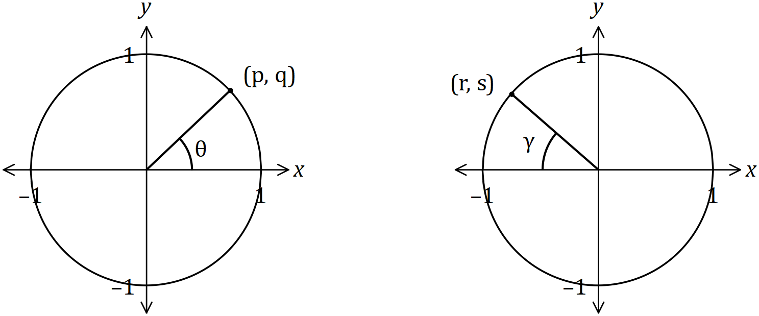

Determine the following in terms of $p, q, r$ and $s$, simplifying your answers where possible.

(a) $\tan{θ}$. (1 mark)
Solutions
(i) $\frac{q}{p}$

(ii) $q$

(iii) $-r$

(iv) $-s$

Specific behaviours
each correct response

(b) $\sin{(180°-θ)}$. (1 mark)

(c) $cos⁡γ$. (2 mark)

(d) $\sin{(π+γ)}$. (1 mark)

Solution
$$\tan\left(-γ\right)=\frac{-s}{-r}$$
$$=\frac{s}{r}$$

Specific behaviours
correct expression

(e) $tan(-γ)$. (2 marks)

Question 21 (8 marks)
(a) For a given set of numbers the set of points is defined as follows:

- State the Domain of (1 mark)
Solution
Hence domain of = ={0,1,2, …,10}
Specific behaviours
- identifies correct domain of

- State the Range of . (2 marks)
Solution
Range of ={0,1,2,3,4}
Specific behaviours
- provides a full listing of the elements of
- states the correct range of

(b) If the set is redefined as follows:

- List the elements of (2 mark)
Solution
Specific behaviours
- provides a listing of the elements of

- State the Range of. (1 marks)
Solution
Range of = ={0,1,2, …,10}
Specific behaviours
- states the correct range of

(c) Comment on whether either of would qualify to be called a function?
Justify your comment. (2 marks)
Solution
is a function, is not as it does not satisfy the vertical line test when graphed (or it has multiple vales for some values i.e. ((2,3) and (2,4) etc.
Specific behaviours
- indicates that is a function and that is not
- states a valid reason

Supplementary page

Question number: _________

Supplementary page

Question number: _________

© 2018 WA Exam Papers. Applecross Senior High School has a non-exclusive licence to copy and communicate this document for non-commercial, educational use within the school. No other copying, communication or use is permitted without the express written permission of WA Exam Papers. SN002-112-4.

